**SPAM MAIL PREDICTION USING PYTHON**

* Importing the Dependencies

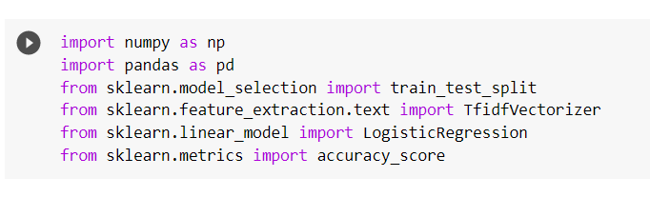

* Data Collection and Pre-Processing

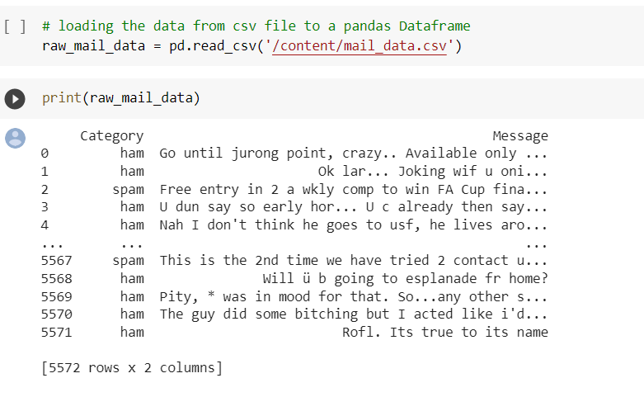

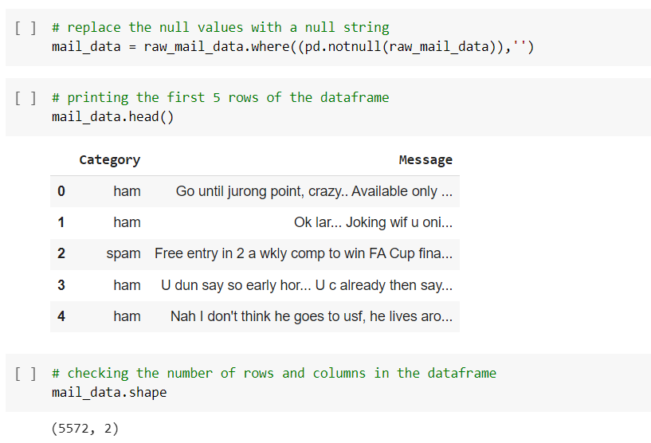

* Label Encoding

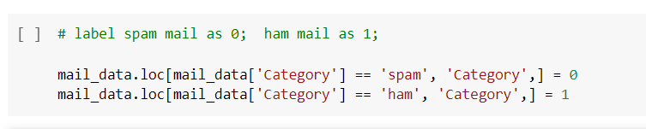

spam – 0

ham – 1

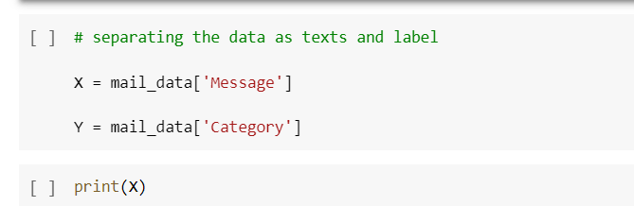

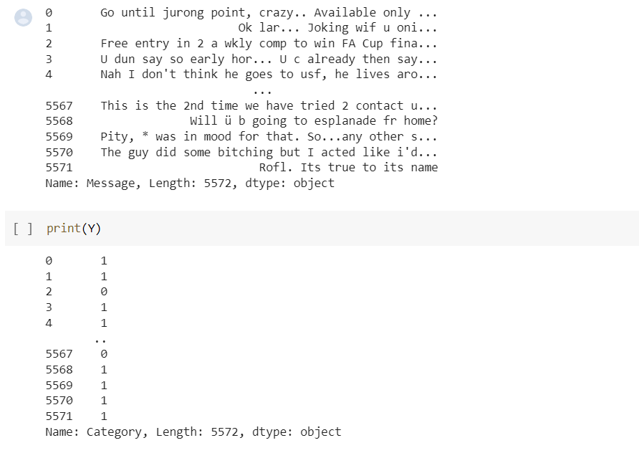

* Splitting the data into training data & test data

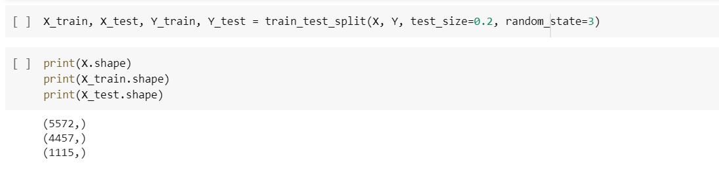

* Feature Extraction

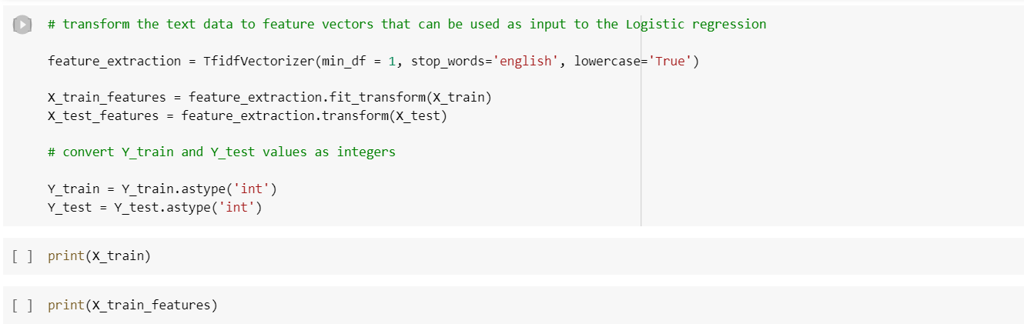

* Training the Model
* Logistic Regression

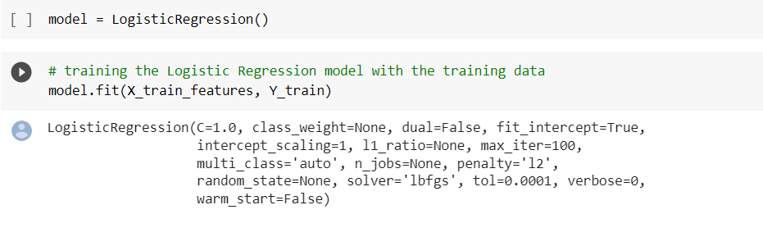

* Evaluating the trained model

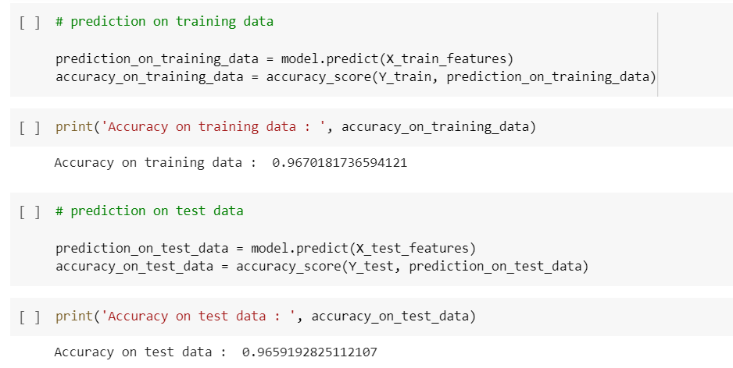

* Building a Predictive System

